Title

VERITAS DLO AGENT INSTALLATION

Prepared By
Backup Team

Date: 16-07-2019

Version 1.0

Document History

Date | Author | Revision | Description
16-07-2019 | Backup Team | Version 1.0 | Document Creation

Approved By: | Tata Business Support Services Limited
Sudhir Challa | Version 1.0

Distribution List
Name | Department | Company | Rights
Backup Team | Technology – Service Delivery | TBSS | Read and Modify
Sudhir Challa | Technology – Service Delivery | TBSS | Verify and Comment
Ali Hyder | Technology – Service Delivery | TBSS | Full and Approve

Security Classification: CBSL Restricted.

Access below screen shot network path \\10.64.194.222 and select DLO Agent folder then double click setup.exe as shown in the screen shot.

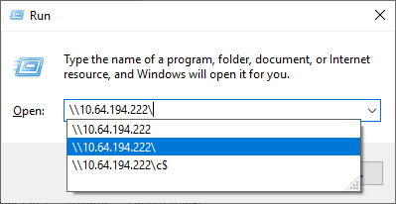

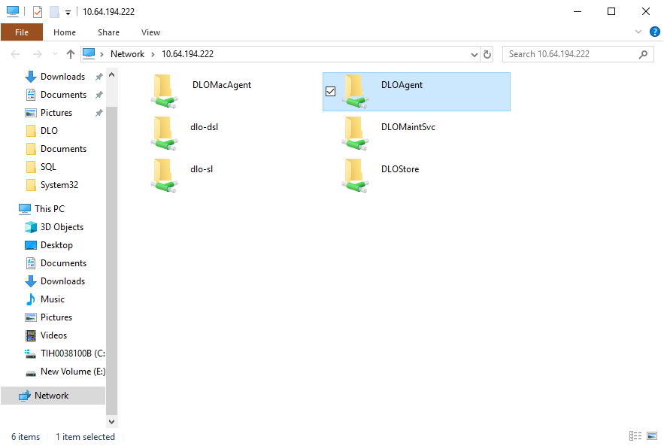

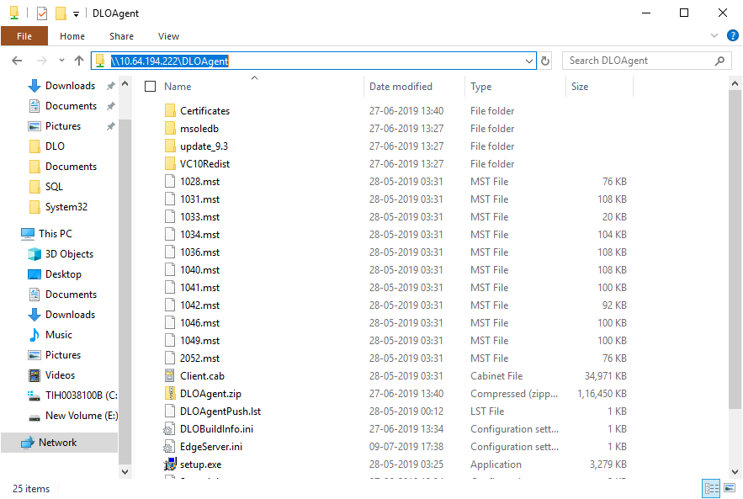

Click on “Run” button and then click “Yes” button to continue in popup window as shown in the screen shot

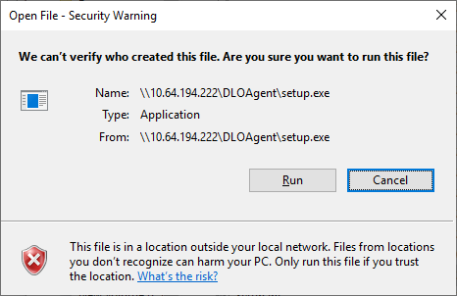

Veritas DLO Desktop Agent window will pop up in desktop and then click next till it’s get completed as shown in the screen shot.
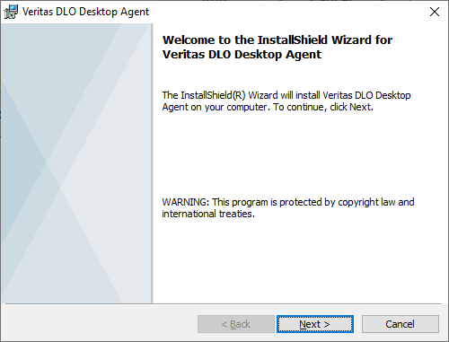

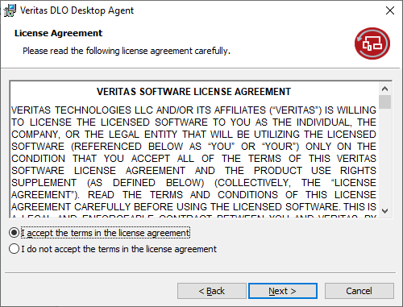
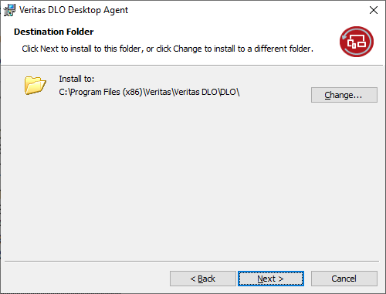

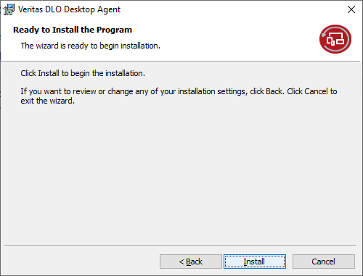
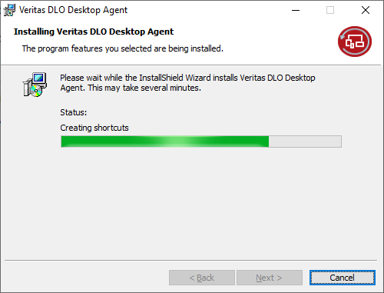

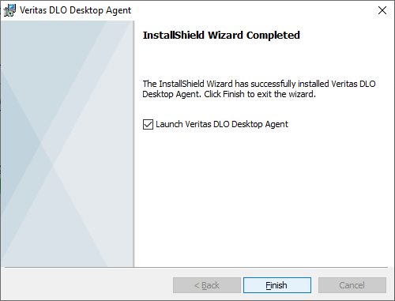

Please make entry “SERVERNAME=59.160.171.105” in EdgeServer.ini by opening notepad with “Administrator” as shown in the screen shots.

File path: C:\Program Files (x86)\Veritas\Veritas DLO\DLO\ EdgeServer.ini

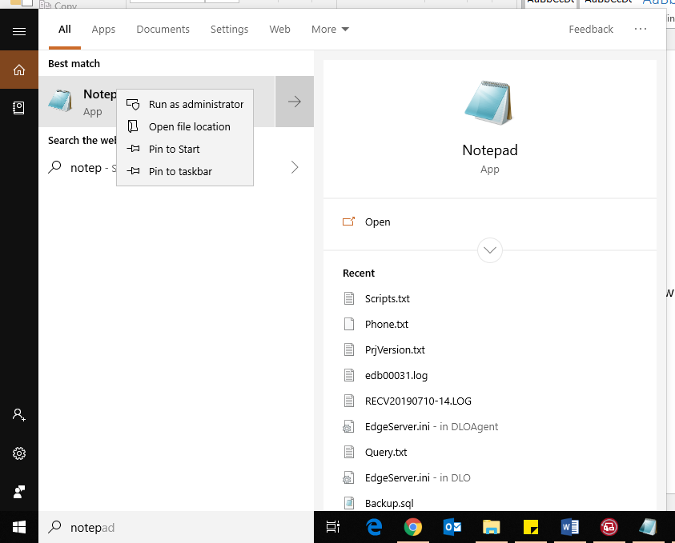
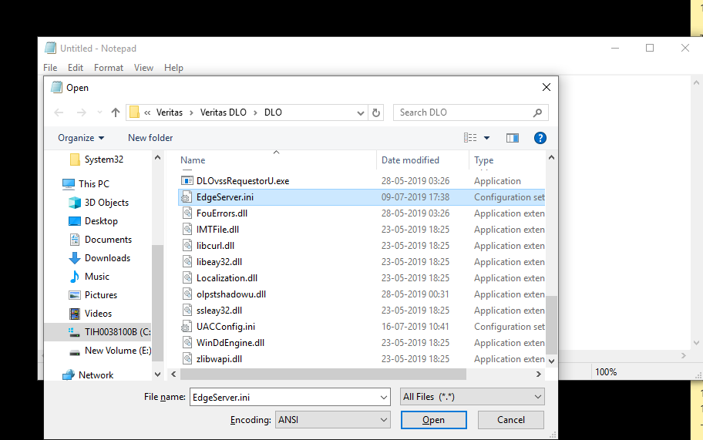

This entry used for to connecting VERITAS DLO agent through internet even though user has not connected VPN or in LAN.
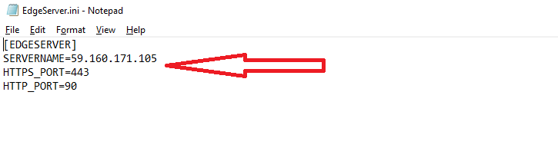
DLO agent status in LAN:

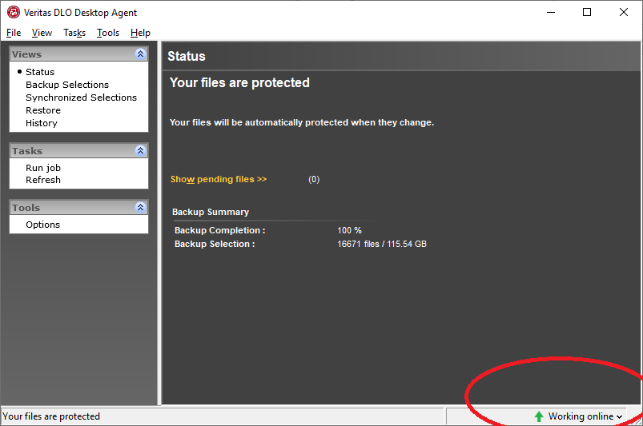

DLO Agent status over in internet

Please inform end user to provide his password in DLO when it prompt so that it will connect to take backup with authentication.

